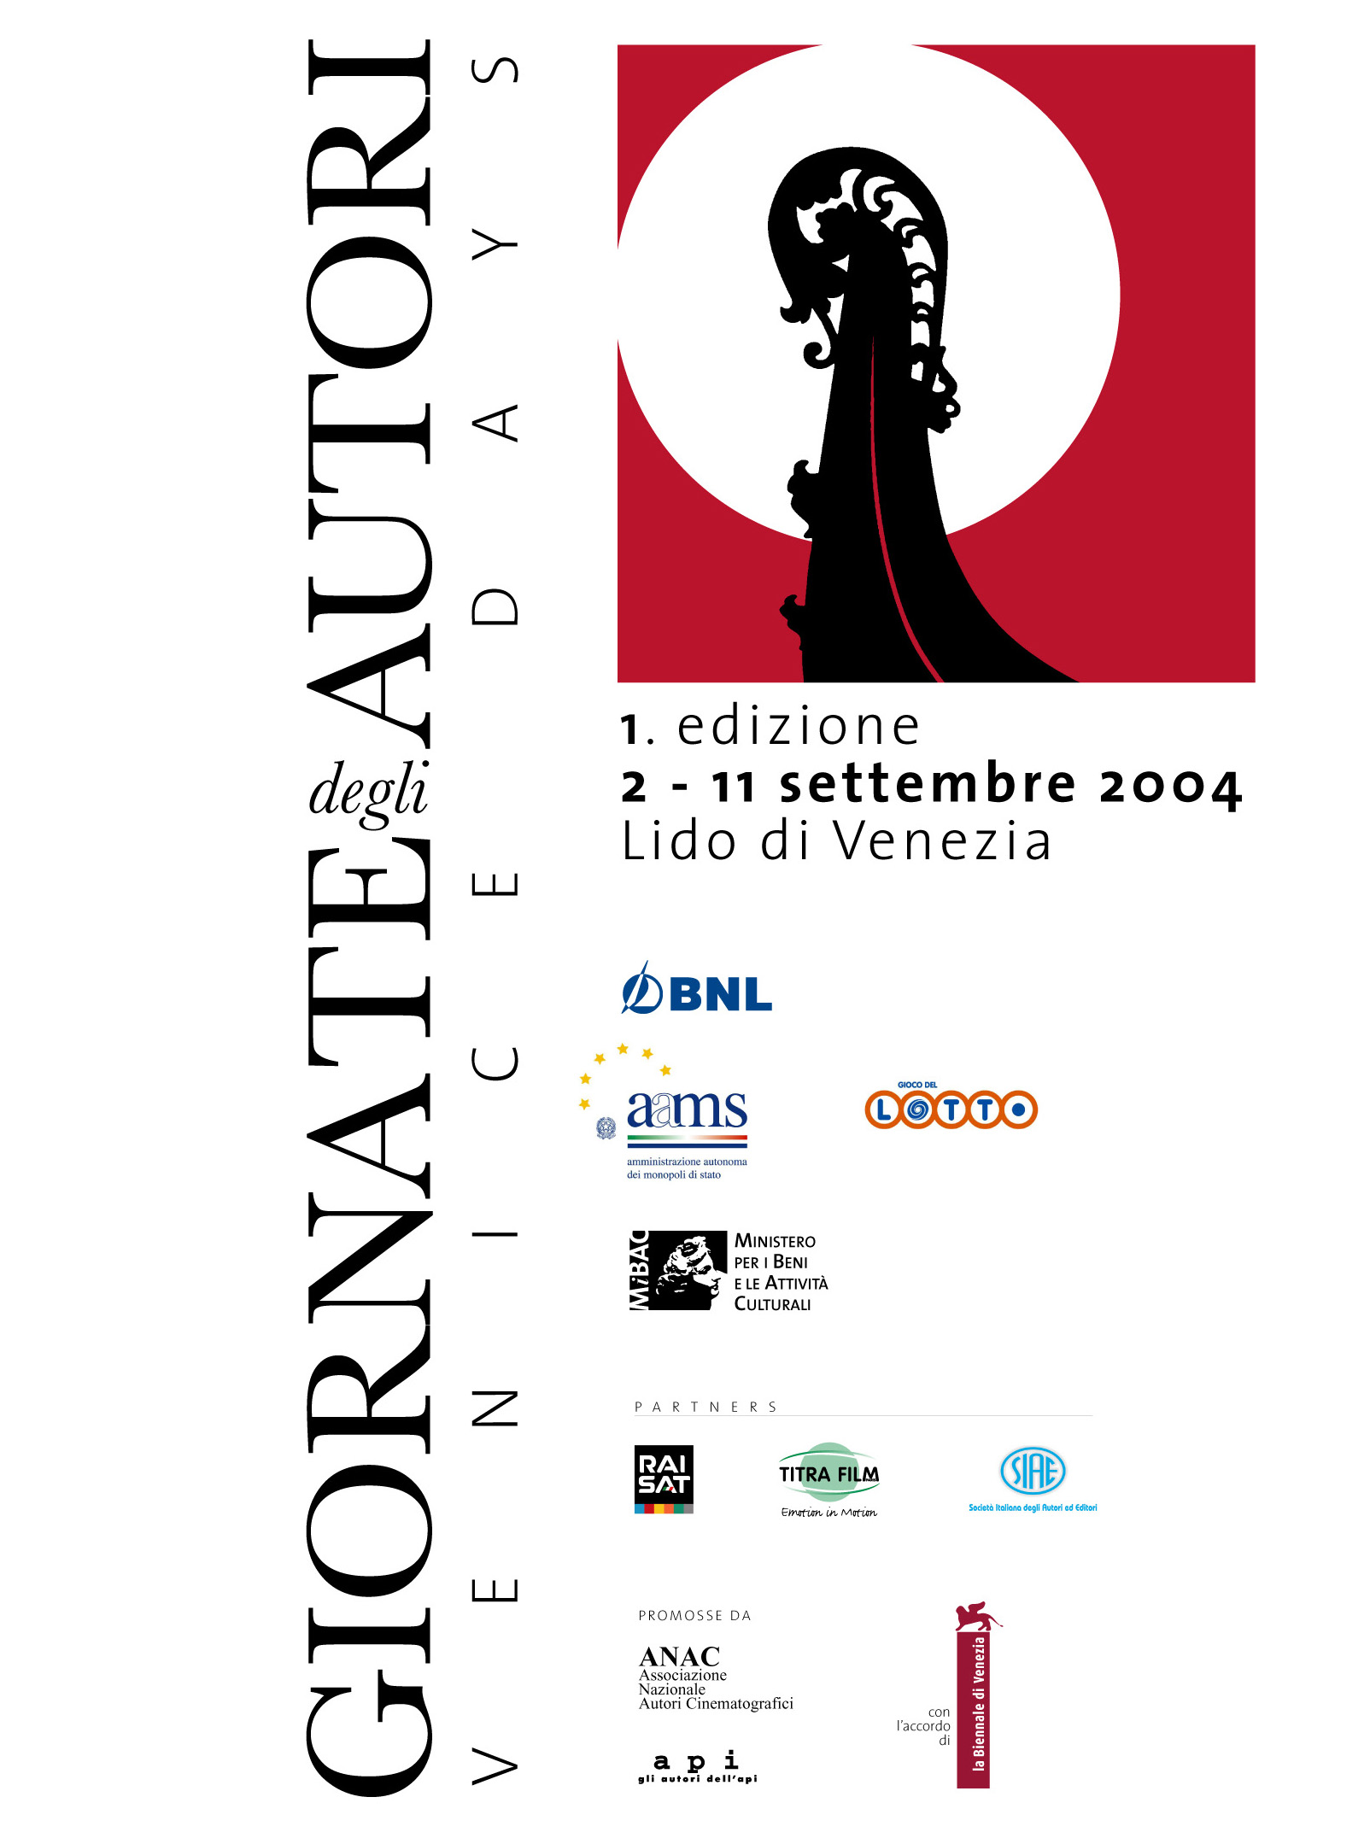

1st edition - 2 / 11 September 2004
The first edition of Venice Days at the 61st edition of the Venice Film Festival will take place from Thursday 2 September until Saturday 11 September. Twelve European arthouse films will be presented as well as two tributes and a special event to be defined. It is being promoted by ANAC (the National Association of Filmmakers) and the authors of API (Independent authors and Producers) in agreement with the Venice Biennale. It is modelled on the Cannes Quinzaine des Réalisateurs and the Berlin Forum des Jungen Films and will have the full support of the Italian Ministry of Culture. Venice Days owes its existence to the support and commitment of private individuals and institutions which have embraced the novelty of this project (first time in Venice) and have worked closely with the promoters right from the beginning. These institutions are the BNL bank, Lottomatica and partners such as Raisat, SIAE e Titra Film – Paris. Many technical sponsors have also contributed in different ways to give “colour” and body to the initiative.
Of the 12 films selected from all of Europe (in the next editions the selection will include not only Europe), seven are First Feature Films - a fact which confirms a profound change in European cinema. Two are by French authors and three are by Italians. 10 nations are represented and the single productions include documentaries, animated films and digital material.
“In addition to using quality and originality of expression as criteria” says Giorgio Gosetti, the director of the showcase, “we have tried to hold ourselves to a principal of need and meaning in the films we wanted to present to the Festival public. On the programme, therefore, there are powerful themes such as the search for one’s roots, forgotten wars, the losing of a job, the impossibility of feeling and violence in the extreme. At the same time there is also a clear desire to question oneself about the practice of “working with images”, on productive forms and on stylistic choices. We are particularly happy that in this respect the foreign selectors with whom we have worked have found Italian cinema to be particularly alive and up to date. I would like to add my special thanks to all those many many people who have believed in our project and to those who have accepted our choices, despite their feelings of rejection, with respect for the honesty behind the attempt”. Thanks to the collaboration of the Vittorio Gassman foundation and the director Marco Risi, the beginning sequence of the “Mattatore’s” last film, Caro Vittorio, will be shown at the inauguration of the section.
During the course of the Festival the director Nico D’Alessandria will be remembered with the projection of his first film L’imperatore di Roma.

THE FILMS

Opening Film - Thursday 2nd September

CONFITUUR
Director: Lieven Debrauwer
Screenplay: Jacques Boon, Lieven Debrauwer
Cast: Marilou Mermans (Emma), Rik Van Uffelen (Tuur), Viviane De Muynck (Gerda),
Ingrid De Vos (Rosa)
Production: K-Line/K2
Foreign Sales Agent: TF 1 International
Press Office: Catherine Piot, TF 1 International Tel. +331 41411223 Fax +33 1 41414296, cpiot@tf1.fr
Belgium, 2004, 87’

Following his first appearance at Cannes in 2001, Lieven Debrauwer comes to Venice Days with his second work, a fiece, bitter-sweet comedy about old age. On the day of his wedding anniversary, Tuur, a craftsman, decides to escape from the house where an old bedridden woman rules with an unrelenting tyrannical hand and runs to his “licentious” sister. This choice fails to bring him the happiness he had hoped for but instead leads to profound and fundamental changes in his solitary life, which start with Emma, his submissive and obedient wife.

Closing Film – Saturday 11th September

A COSTA DOS MURMÚRIOS / THE MURMURING COAST
Director: Margarida Cardoso
Screenplay: Margarida Cardoso, Cédric Basso
Cast: Beatriz Batarda (Evita), Filipe Duarte (Luis), Monica Calle (Helena),
Adriano Luz (Forza Leal)
Production: Filmes do Tejo
Portugal, 2004, 115’

In the year in which the Festival celebrates the oldest of the Portugese directors, Venice Days concludes with a young artist from the same country. Her debut film is a journey through the memory of a people, the end of the colonial period, the redemption of feminine emotion and the discovery of an absurd war which was lost before even reaching its conclusion. The setting for this subdued collective tragedy is the white man’s Africa, on which lies heavy the ghostly silence of those native to that earth.

First Feature Film

Selection

Friday 3 September
PREDMESTJE – SUBURBS
Director and Screenwiter: Vinko Möderndorfer
Cast: Renato Jenček (Marjan), Peter Musevski (Fredi), Jernej Šugman (Slavko),
Silvo Božič (Lojz)
Production and Foreign Sales Agent: Forum Ljubljana
Press Office: Nerina Kocjancic, Tel: + 386 1 431 31 75, Fax: + 386 1 430 62 50
e-mail: nerina.kocjancic@film-sklad.si
Slovenia, 2004, 90’

In the suburbs of present day Slovenia, life continues as it does in all suburbs: among the drinking, the useless bowling matches, the daily violence and the suffering due to the inevitable realisation of life’s insignificance. Death, voyeurism and even the echo of rage and war seem enveloped in cotton. But for Marjan and his friends, destiny has other things in store. Presently in competition at the Montreal Film Festival, this film appears in Venice on its world premier in accordance with international festival rules and regulations.
First Feature Film

Saturday 4 September
STRINGS
Director: Anders Rønnow Klarlund
Screenplay: Naja Marie Aidt, Anders Rønnow Klarlund
Characters: Kharo, Nezo, Ghrak, Erito
Chief Puppetteer: Bernd Ogodnik
Puppet maker: Joakim Zacho Weylandt
Sound: Hans Møller
Production: Bald Film
Foreign Sales Agent: Trust Film Sales
Press Office: Fusun Eriksen, Trust Film Sales, Tel. +45 36868788 Fax +4536774448
post@trust-film.dk
Denmark, 2004, 92’

A kingdom, a fight for power, two youths who fall in love against the wishes of their respective families: it could be Shakespeare or it could be “The Lion King”. Instead it is a story of puppets, which although hand cut out of wood, are more alive than many humans. And someone pulls their strings until they are broken by destiny. This might be the European answer to the industrial magic which has turned animated design into a digital art. Rather it is above all the redemption of a timeless craft, the European voice of an ancient deeply rooted culture: the culture of the fairy tale.

Sunday 5 September
IL GIORNO DEL FALCO
Director:Rodolfo Bisatti
Screenplay: Rodolfo Bisatti, Maurizio Pasetti
Cast: Stefano Cassetti (the Chinese man), Mario Rodighiero (the old man), Giacomo De Domenico
(the journalist), Mario Pigatto (the cameraman)
Production: Ipotesi Cinema
Italian Distribution: Mikado Film
Press Office: Roberta Avolio, Mikado Film, Tel. 06 3244989, Fax 06 3219489, r.avolio@mikado.it
Italy, 2004, 87’

From the “Conjectural Cinema” laboratory of this is a film about the baroque nothingness in the North East. A local television station, a desperate robbery, a “Spoon River” type song to the bountiful earth. The main characters are an ex university professor now TV reporter, his disillusioned cameraman, two fools who have robbed a bank in perfect Butch Cassidy and the Sundance Kid style, a faceless policeman and a friend who would rather be anywhere but where he is. A model of low budget filming, this work is a balance between visionary fantasy and the rigid documentation of real life which speaks of an earth and a people who we think we know but who seem to inhabit another galaxy.
First Feature Film

Sunday 5 September
L’OEIL DE L’AUTRE / NOW AND THEN
Director: John Lvoff
Screenplay: Camille Fontaine, John Lvoff
Cast: Julie Depardieu (Alice), Dominique Reymond (Juliette), Eric Elmosnino (Jérôme)
Production: Pierre Grise Productions
Press Office: Sandrine Pillon, Pierre Grise Productions, Tel. +33 1 40279906
Fax +33 1 40279716 pierre-grise-productions@wanadoo.fr
France, 2004, 90’

Taking pictures, framing reality and documenting the passage of time and man can either be considered an art form or a job, but it can also become a pretense to search, to see “beyond” and to intercept one’s own destiny as well as that of others. Alice, a photographer (Julie Depardieu), follows the clues of the strange disappearance of the English photographer who preceded her. In the end, the reasons for his disppearance will be revealed by his last shots from in front of an old ruin - images which hide the solution to a mystery which no camera could ever capture.

Monday 6 September
TARTARUGHE SUL DORSO
Director and Screenwriter: Stefano Pasetto
Cast: Barbora Bobulova (The girl), Fabrizio Rongione (The boy), Gordana Miletic (The Aunt)
Original Music: Banda Osiris
Production: Sintra
Italian Distribution: Istituto Luce
Press Office: Maria Antonietta Curione, Istituto Luce Tel 06 72992242 Fax 06 7221127 stampa@luce.it
Italy, 2004, 92’

A boy, a girl, a city and an ignorant love which lasts for years and is always interrupted by violence. A turtle and a game of Scrabble reconstruct and upset the destinies in this love story in which destiny itself is perhaps the only character to know what will happen next. The city is Trieste, a typical border city; a grey line between the youth of the main characters and the other’s fatigue. Banda Osiris, on the look out for another success to follow Primo amore, provides the music
First Feature Film

Tuesday 7 September
DEAD MAN’S SHOES
Director: Shane Meadows
Screenplay: Paddy Considine, Shane Meadows
Cast: Paddy Considine (Richard), Gary Stretch (Betts), Toby Kebbel (Anthony)
Production: Warp Films Ltd
Foreign Sales Agent: Element X
United Kingdom, 2004, 86’

This story unfolds in three time periods: the past, just yesterday and a livid and brilliant present day, set in a provincial English background. It begins in sport and ends in tragedy and unravels on the edge of a mysterious vendetta. Following his appearance in Venice with Twentyforseven, this work definitively confims Shane Meadows as one of the most unclassifiable and vital talents in British cinema, capable of transforming the harsh social realism of the lumpenproletariat into an apologue of betrayed friendship and shattered feeling.

Wednesday 8 September
NEMMENO IL DESTINO
Director: Daniele Gaglianone
Screenplay: Daniele Gaglianone, Giaime Alonge, Alessandro Scippa
Cast: Mauro Cordella (Alessandro), Fabrizio Nicastro (Ferdi), Lalli (Adele),
Stefano Cassetti (Lorenzo)
Production: Fandango, Armadillo
Italian Distribution: Fandango
Foreign Sales Agent: The Works
Press Office: Daniela Staffa, Tel. 06 97745023 Fax 06 97745020 ufficiostampa@fandango.it
Italy, 2004,110’

The destinies of three adolescents cross in a school in the underworld of Turin. Alessandro and his classmates will never be happy nor will they ever achieve even a semblance of serenity. After a suicide, a disappearance, a house in flames, a mother who goes insane and a father who is never around, Alessandro ends up in a reformatory and his friends abandon him, fragments of a life captured by an ultra modern, restless camera. This film is based on the novel by Gianfranco Bettin and is the second work by the author of Nostri anni.

Thursday 9 September
DARWIN’S NIGHTMARE
Director and Screenwriter: Hubert Sauper
Editor: Denise Vindevogel
Sound: Veronika Hlavatsch
Production: Mille et une productions, Coop99, Saga film
Foreign Sales Agent: Celluloid Dreams
Austria / France / Belgium, 2004, 107’

In the 1960's, in the heart of Africa, the “Nile Perch” was introduced artificially into the lake Victoria where it extinguished 95% of the native fish species. However, the voracious predator's fillets are a delicacy and the booming multinational food industry it brought with it has created an ungodly, globalized alliance of local fishermen, Indian factory owners, African ministers, Russian pilots and local prostitutes. Huge hulking ex-Soviet cargo planes come to collect the latest catch in exchange for their cargo of kalashnikovs and ammunitions for the uncounted civil wars, leaving behind the bewildered inhabitants of small townships struggling to understand the laws of the new world economy.
First long Film

Friday 10 September
4
Director: Ilya Khrzhanovsky
Screenplay: Vladimir Sorokin
Cast: Marina Vovchenko (Marina), Sergey Shnurov (Volodia), Yury Laguta (Oleg)
Production: Filmocom
Press Office: Alexandre Koulch, Filmocom, +791-61462169, blacklizard@yandex.ru
Russia, 2004, 126’

On a freezing night in Moscow punctuated by the howling of wild dogs, three destinies are briefly crossed. A woman and two men are linked together through their imaginings of lives which will never be lived. The dazzling debut of the heir of the number one Russian director of animated films, this film is based on the most scandalous and forbidden best seller in new Russia. The result is the depiction of a world which is suspended between visionary realism and imaginary science fiction; a composite and angry portrait of a society entirely lacking in certainty.
First Feature Film

Special Events

Thursday 2 September
Tribute to Vittorio Gassman
CARO VITTORIO
When Marco Risi first started filming what was going to be an assembly of the entire artistic heritage of the great “Mattatore”, he had no idea that there would be enough time only for the beginning sequence.
Thanks to the help of the director, of Sorpasso Film and the Gassman Foundation, these first scenes will be shown to the public, with an extra unexpected twist....

Thursday 2 September
MORASSEIX
Director: Damien Odoul
Screenplay: Damien Odoul, Antoine Lacomblez
Cast: Damien Odoul (César), Pascal Pagnat (Douze), Audrey Bellessort (Lili)
Production: D.O.Films
Foreign Sales Agent: Wild Bunch
Press Office: Elise Girard, Tel. +33 1 42 78 17 95, elisegirard@wanadoo.fr,
France, 1992-2004, 91’

Written and directed by the film’s director at the time of his debut, this is the lost film of the prodigal child of French cinema. Starring the same director, this is a chronicle of anger without reason and the private war of a group of youths on the outskirts of rural France.
The founding member of an aesthetic of unease ever more diffuse in European cinema, Morasseix is not a relic of the past. Instead it is a new and contemporary work by an author who comes to Venice to tell the story with roots that only appear to lie in the past.
First Feature Film

Friday 3 September
Tribute to Nico D’Alessandria
L’IMPERATORE DI ROMA
Director: Nico D’Alessandria
Cast: Gerardo Sperandini, Nadia Haggi, Giuseppe Amodio
Italy, 1987, 90’

The most desperate and solitary of the independent Italian authors is remembered at Venice Days with his debut film, a dazzling trip through historical Rome and the city of the homeless and lawless. It is a chronicle of the hoplessness of Gerry the drug addict’s cast off life. This tribute is given with all our affection for what will always remain the “imaginary friend”.

Authoritatively yours: the Author’s cinema

For the first time in the history of the Venice Film Festival there will be a new space for free cinema, complete with new talents, new stories and never seen before films.
Venice Days, organized by ANAC (the National Association of Cinematographic Authors) and the authors of API (Independent Authors and Producers) in complete agreement with the Venice Film Board will fill ten days of the biggest international Italian festival (from 2 to 11 September) - in their own inimitabile and recognisable style - with culture, entertainment, participation and celebration.
The fulfilment of the project Venice Days has been entrusted to the critic and festival director Giorgio Gosetti, on the model of the glorious event at Cannes, the Quinzaine des Réalisateurs and in complete programmimg harmony with the Berlin Forum des Jungen Films Both of these showcases will be ideally and operatively linked to the new Venetian section.
The events will take place in three well known venues, dedicated to all the authors present at the Festival. Here the Italian authors will act both as hosts and as principal characters: the Palagalileo, where the films selected for the showcase will be screened (priority access given to the press) and where meetings with the public will be held; the Author’s Villa where there will be daily meetings, discussions of the day’s topics in addition to a bit of healthy entertainment; and the Raisat Terrace where every evening the authors of Venice Days will be joined by the Festival guests.

Why a new space for the Festival?

When the Quinzaine des Réalisateurs was founded at the Cannes Film Festival in 1968 the French authors, in contention with the Festival, intended to create an independent space which would differ profoundly in style and idealism from the event at that time.
Throughout the years the SRF (Société des Réalisateurs Français) has supported and nurtured this independent space allowing it to grow into what it is today, one of the most significant events in international quality cinema, and transforming it little by little into an opportunity for discovery, research and innovation.
A similar thing happened at the Berlin Festival with the creation of the Internationales Forum des Jungen Films to give voice to those talents and that cinema and language that was rarely given a chance to speak out in the official sections. In this case too, with time, this parallel event has grown with the Festival while still maintaining a completely independent and recognisable character all of its own.
The creation of a similar space at the Venice Film Festival based upon these same characteristics will allow the Italian authors to recover the experience of direct commitment, offer alternative routes and ways which are different and parallel to the official section. An accent will be placed on the idea of an “author’s free space” on a circulation of ideas, and on the people and expressive innovations which are an inherent part of the title Venice Days.

The fulfilment of a project

This showcase is promoted by the cinematographic authors of ANAC and the authors of API in agreement with the Venice Film Festival Board.
In order to accomplish this project the cultural association “Venice Days”was founded. It is presided over by president Roberto Barzanti, vice presidents Emidio Greco and Francesco Maselli and, upon indication from the two associations, has the following partners: Giuliana Gamba, Francesco Ranieri Martinotti, Massimo Sani, Valerio Jalongo, Andrea Purgatori and Maurizio Sciarra.

The director of the project is Giorgio Gosetti, former vice director of the Gillo Pontecorvo Film Festival (1992-1996), director of Italia Cinema and then of Audiovisual Industry Promotion, director of the Courmayeur Noir in Festival and an Ansa journalist.
Sector professionals, international experts, and young students from Dams in Bologna have joined Giorgio Gosetti in the fulfilment of this project.

The committee consultants is made up of the critics Agnès-Catherine Poirier, Tadeusz Sobolewski and Adrian Wootton.

Venice Days is closely linked both to the Quinzaine and to the Forum thanks to the close artistic collaboration and the helpfulness of the selectors Olivier Père and Christoph Terhechte.

The films will be competing for the “European Cinema Label Award” for the promotion of cinema in Europe, established by the European "réseau" of quality traders and with the support of the EU MEDIA programme – Media Plus. The prize, which amounts to economic support for the distribution and the lasting run of films in member cinemas has only been assigned at the Quinzaine in Cannes since it was first awarded in 2003.

The Venetian jury is made up of Michel Demopoulos (Greece), Matthias Elwardt (Germany), Roman Gutek (Poland) and Georgette Ranucci (Italy).

Any first works will be eligible to compete for the "De Laurentiis Prize", along with all other debut films from the other official sections.

Venice Days will be inaugurated on 2 September in the Sala Grande. The official screenings will take place at the Palagalileo at 11.30 every day and there will be a chance to meet the cast after the screening. Various special programmes have been arranged with the Festival Board and will be announced in due time.

The Authors Villa will be the venue for a programme of daily meetings, special events, press conferences and presentations from early morning until late at night.

Comment

What need is there for another type of programming, a new section, or a new selector in a festival as large as the Venice Film Festival?
One can respond to this question recalling to mind the composite character and dialectical vitality of all the European models, Venice included: different paths, different tastes, differing motivations, parallel objectives. One can recall the youthful independent character of all these events (from the Quinzaine to the Forum) and how the whole project is enriched as a result. Finally one can stress the meagreness of this section (barely a dozen titles) which already in its format presents itself as an unavoidable alternative to the excesses of the grandiose programming which has characterised the larger festivals over the years.
It is our opinion that the real need lies in the facts: in the capabilities of the authors to use this space as a real stage upon which to exchange ideas, research, and knowledge, in an affirmation of this new and different way of making films.
In this spirit, for this inaugural year, the selection has been considered in a European prospective. We are convinced that the cultural roots intercepted in a project of a European idea of culture have the ability to reflect themselves and strengthen their identities through comparison rather than disappear.
Both the director and the international committee of consultants at his side used the same criterion to chose the films. Considering that the market is vast but not infinite (over 280 films were offered or requested) and that production follows the stream of creativity (the famous theory of the “mushroom years” put forth by Gillo Pontecorvo) the chosen films differ greatly from one another. Witnesses to a great generational exchange, they come from 10 different nations,– seven of them are first works – and present themes, productive methods, and expressive stories, which have a lot to do with the debate on the present and future of Italian cinema.
A strong and vital mosaic will be available to cinema lovers during the 10 days of Venice Days. The novelty of the initiative, carried out in agreement with the Venice Biennale, has been greeted with real enthusiasm by those industry professionals who have created the selected films but it has also been encouraged and watched by those whose films were not chosen. Many international festivals, as well, have offered suggestions and advice. Foremost among these, as hoped, are the delegates from the Quinzaine and the Forum who accepted to tie their respective events with that of Venice Days.
In closing we would like to say a word on present day Italian Cinema which has come to the Festival this year in its most difficult moment, albeit richer in talents and propsals. We are proud that there are two first works and one second work in our programme and are truly sorry to have had to refuse other films and other authors that would have profited from our support and encouragement.
The choices were difficult but necessary and to us it seemed right to weigh the Italian authors just as all the others, in a completely impartial way. In our opinion, the new refreshing heritage of ambitions and attempts which characterises the latest Italian production is of fundamental importance. However, it must not be forgotten that it is a heritage and as such risks being lost in the uncertain structural condition of our cinema today. For this reason, as well,Venice Days has a mission: to testify to that which may be as well as to that which may no longer be.

WHO WE ARE

President - Roberto Barzanti

Direction- Giorgio Gosetti

Coordination - Francesca Palombelli

Programme - Gaia Furrer

Marketing - Sylvain Auzou

Communication- Giovanni Marco Piemontese

Technical Organization - Raffaele Striano e Roberta Ria
in collaborazione con Carlo Lanfranchi

Administration - Fabio Angelilli

Desk - Simonetta Pacifico

Images - Maria Teresa e Antonella Pizzetti

Catalogue Editor - Claudia Bergonzi

Translations - Toril Brinck-Johnsen

Press Office
Arianna Monteverdi
Studio Sottocorno
Via Nino Bixio, 38 - 20121 Milano
Tel. 02-29419283 fax 02-2049681
Cell. 338-6182078
Email info@sottocorno.191.it
in collaboration with Manuela Cavallari, cell. 349-6891660

technical partners

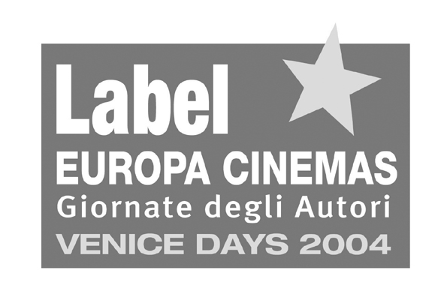









The hospitality in Villa degli Autori is in cooperation with
PROVINCIA DI TREVISO – CITTA’ DEL VINO – BUONITALIA – CARRYON

